This whole document is based on Jeremy Ethier’s videos.

Chest
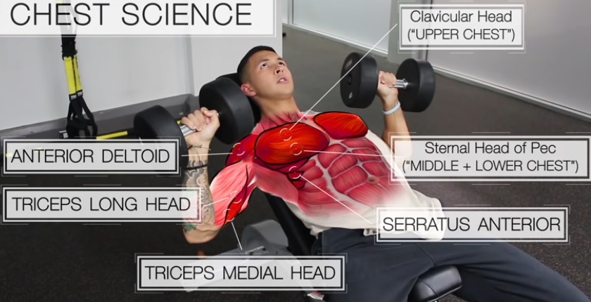
Since the upper chest fibers run upward, the upper chest is best activated with exercises that involve the arms moving upward as shown below:
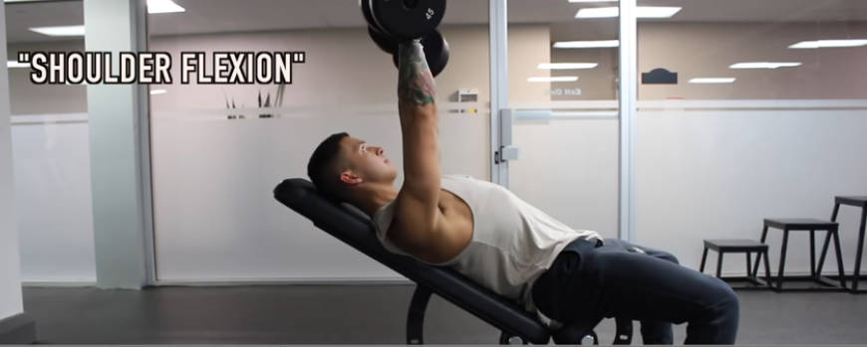
Since the middle chest fibers run horizontally, the middle chest is best activated with exercises that involve the arms moving directly horizontally as shown below:
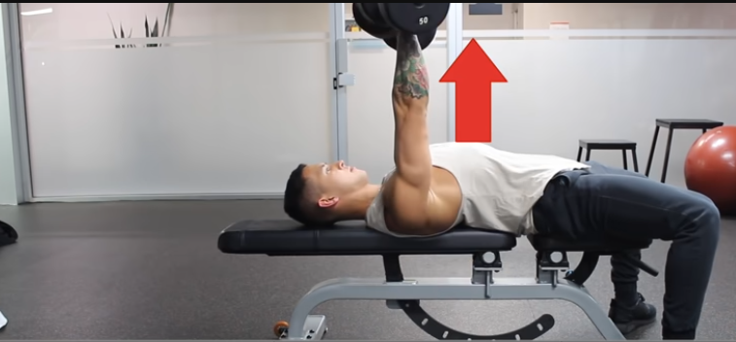
Since the lower chest fibers run downward, the lower chest is best activated with exercises that involve the arms moving downward as shown below:
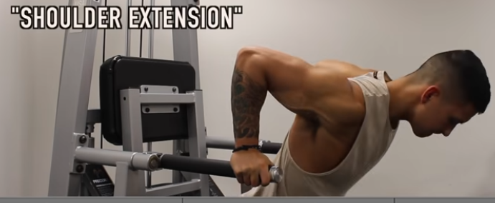
$$-$$ | Upper Chest | Middle Chest | Lower Chest
Exercises | Inclined Bench Press  Pushups | Flat Bench Press  Pushups  High-to-Low Cable Crossovers | Chest Dips  High-to-Low Cable Crossovers  Declined Bench Press
- Clavicular head = upper chest.
- Sternal head = middle chest.
- Abdominal head = lower chest.

Back
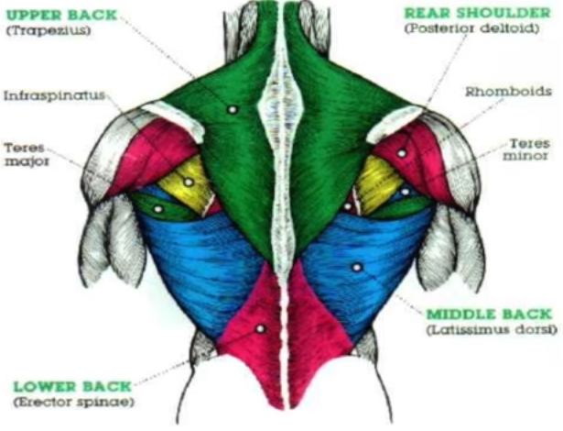

Triceps
The triceps are composed of three heads:
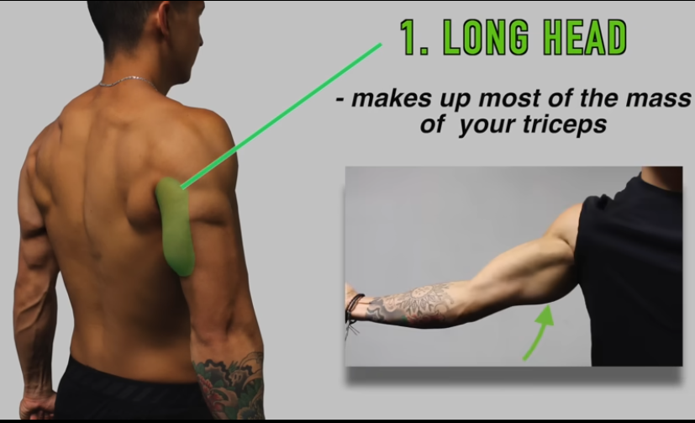
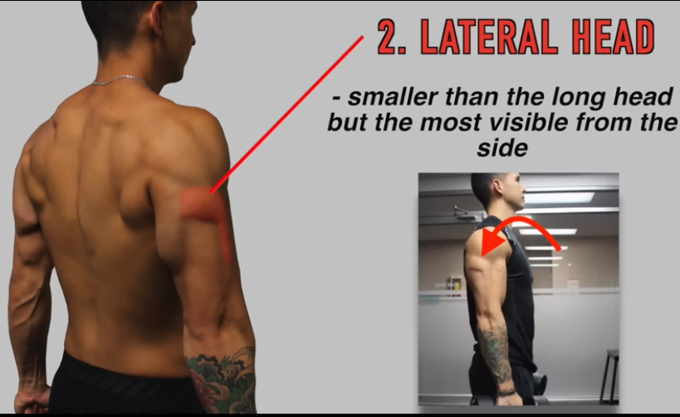
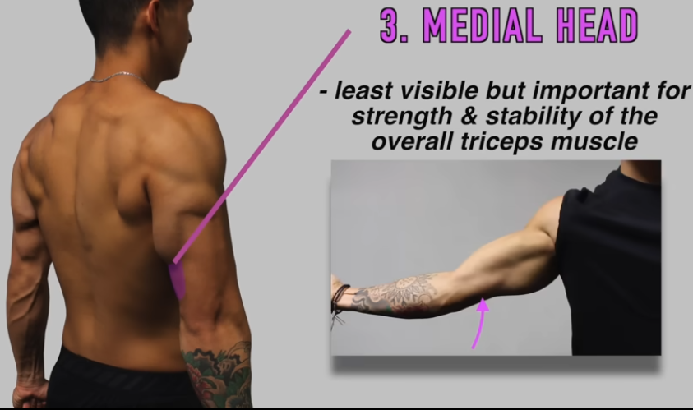
Exercises and Targeted Heads:
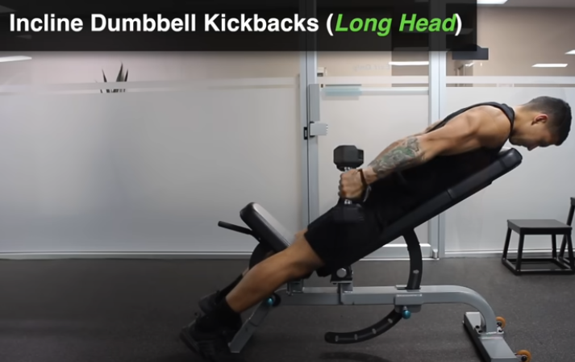
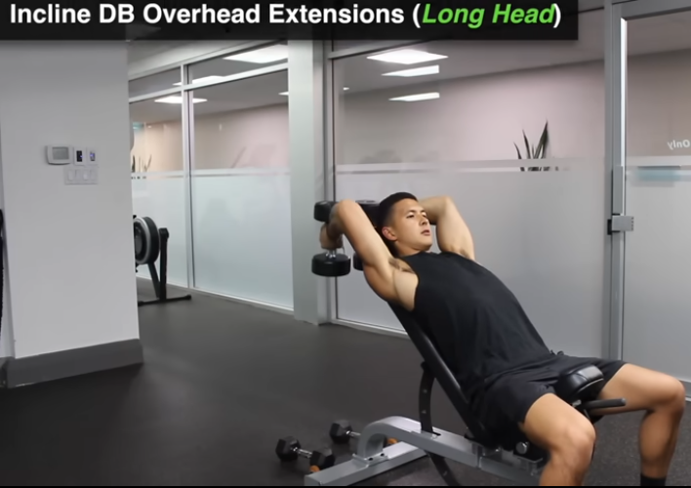
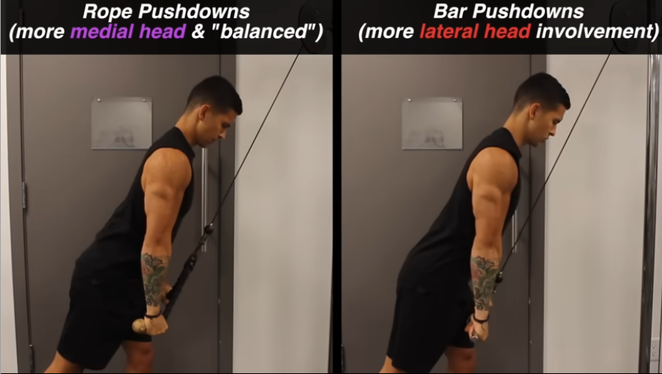
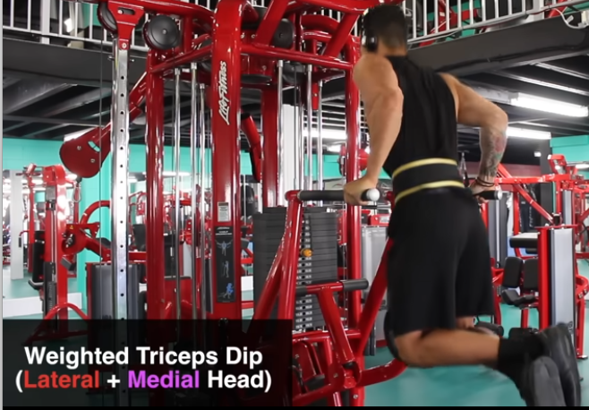

Biceps
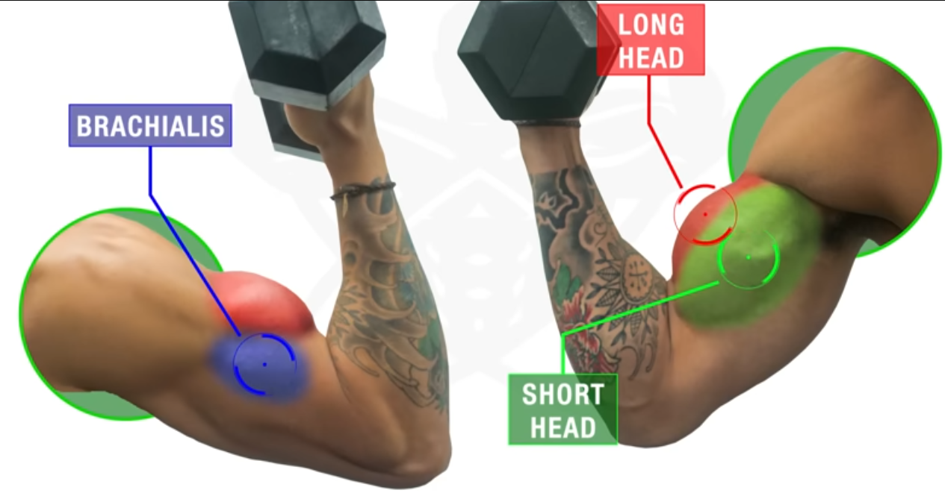
$$-$$ | Short Head | Long Head | Brachialis
Exercises | Seated Concentration Curl | Incline Bench Dumbbell Curl | Hammer Curls

Legs
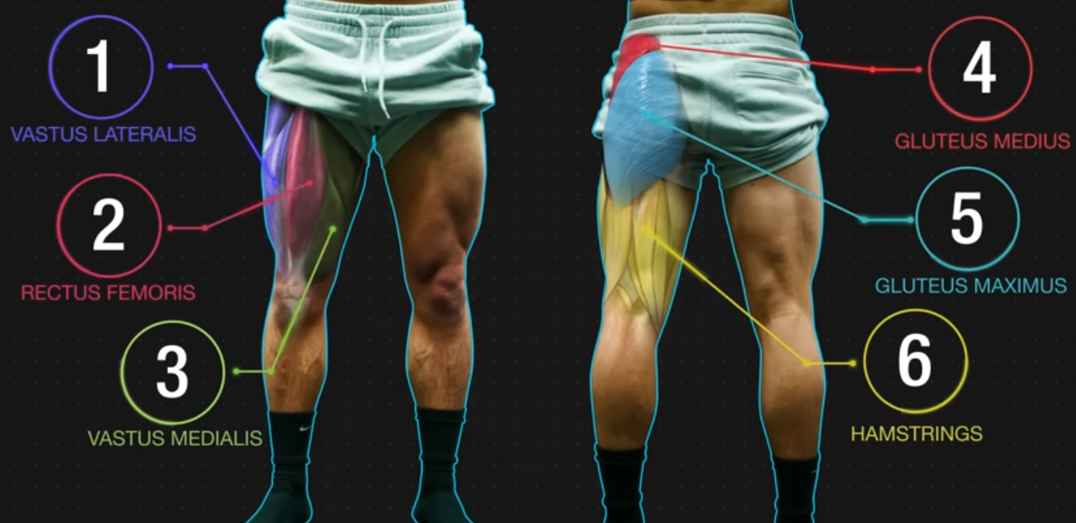
Quad amameya
Hamstring 5alfeya
Glutes mo2a5era

Abs
